Thrive webpage
Home

The Thrive Archive is an online resource of creative projects, images and experiences to share heritage, celebrate diversity and inspire community arts.
This pioneering creative arts consultancy offers a practical template for communities and their local artists and craft makers to help create their own innovative and sustainable cross-arts projects.
The Thrive Archive can help you tell and share your own stories in new and exciting ways to reflect the rich diversity of culture in Scotland today.

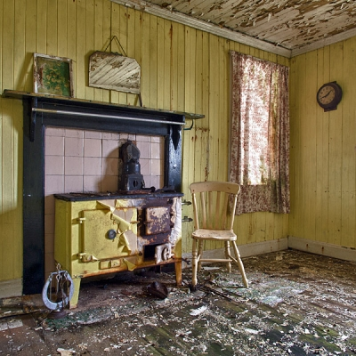
photo credit Ian Paterson

About
From inner cities to remote islands Thrive curator Jan Bee Brown has 25 years of experience of visual storytelling as a collaborative artist, curator and theatre designer.
The collaborative art process is like skimming a stone across a loch.
An unusual pebble catches your eye you weigh it in your hand, launch it with your best shot and hold your breath as you count the bounces before the final ‘plop’.
If the pebble is your story and the bounces are the creative process then the plop is the performance. The resulting ripples are new projects inspired by the process.
There are artists and stories in every community and we want to hear from you. Contact us suggesting a story, a school, a day-care centre, and a venue you want to work with. Perhaps you have a potter and a poet but need a puppeteer or an opera singer to tell your story? Thrive can make it happen.

At The Thrive Archive we have an ensemble of professional artists, performers, singers, musicians and makars and our curator will enable tailor made workshops in your community to develop your project and document the process. The creative journey and the resulting performance, gaitherin or exhibition and will feature on The Thrive Archive Website to inform and inspire new projects through social media.

Your story gets told, your community takes ownership and the community starts to thrive.

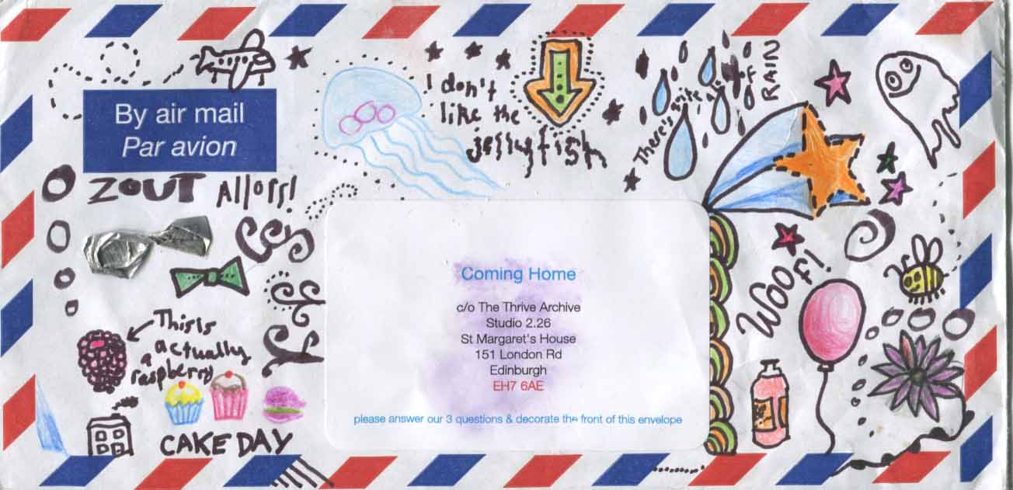

Projects

Using the Thrive template as a resource, every community can develop, market and evaluate an eco-friendly collaborative arts project within a sustainable budget. Whatever their ‘craft’ local artists get professional development that can lead to new contacts. new projects and opportunities.

Coming Home is a pilot project combining traditional music, photography, film and VJ visuals for The Thrive Archive sponsored by Enterprise Music Scotland take a look at our first blog: www.facebook.com/thethrivearchive

